Science
Living Things and their Habitats-
- Recognise that environments can change and that this can sometimes pose dangers to living things
- Describe how living things are classified into broad groups according to common observable characteristics and based on similarities and differences including micro-organisms, plants and animals.
- Give reasons for classifying plants and animals based on specific characteristics.
Art
Cityscapes – the study of various artists and their techniques when creating cityscapes:
- 3d Pop Art-Textured Appearance
- Silhouettes
- Reflections
- Creating an ink drawing.

PE
- Cricket
- Athletics
- Tennis
- Rounders

RE
Worship
- Explain what worship is
- Make the link between worth and worship
- Understand prayer
- Discuss religious art and artefacts
English
Significant Author (Macbeth)
- Recount
- Poetry
- Letter Writing
-Personal writing
-play scripts

Independent Writing
- Greek Myths

End-of-year Play
-Prepare poems and plays to read aloud and to perform,
-showing understanding through intonation,
-tone and volume so that the meaning is clear to an audience

Music
End of Year production
Singing – choral and solo arrangements. End of Year Performance

DT
Fairground-design, build and create their own rotating fairground rides:
- pulley and belt systems
- electrical circuits with motors
- Design and create their own ride
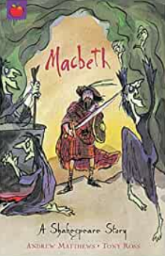
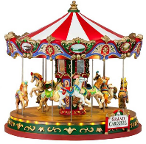
YEAR 6 SUMMER TERM
CURTAIN CALL
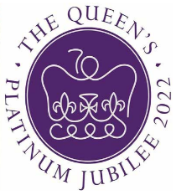
RHE

- Mental Wellbeing
- Changing adolescent body
- Sexual Intercourse

Geography
Maps incorporating Fieldwork
- Follow a short route on a OS map Describe the features shown on an OS map
- Use atlases to find out data about other places

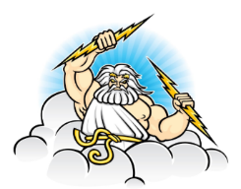

The Queen’s Diamond Jubilee

English
‘The London Eye Mystery’ by Siobhan Dowd.
Biography
The Queen – Jubilee celebrations

Geography
- Population changes around the world and reasons for the changes.
- Geographical history of London and population changes

History
- History of the Monarchy
- A timeline of the Queen
Computing
- Using and applying
- Radio Station

Maths
Statistics
- Interpret and construct pie charts and line graphs and use them to solve problems
- Calculate and interpret the mean as an average.

Properties of Shapes
- Draw 2D shapes using given dimensions & angles
- Recognise, describe & build simple 3D shapes inc. nets.
- Compare and classify shapes based on their properties & sizes & find unknown angles in any triangles, quadrilaterals and regular polygons.

Consolidation and Themed Projects
The projects provide an opportunity to revisit many of the skills and curriculum content covered both in Year 6 and also the rest of Key Stage 2. They provide an opportunity to ensure any possible gaps in understanding are addressed before children move on to secondary school.

History
Ancient Greeks- a study of Greek life and achievements and their influence on the western world.
- To explore some of the key events during the ancient Greek period.
- To examine how Alexander the Great’s Empire grew and the effects of this.
- To make connections and draw contrasts between life in ancient Athens and life in ancient Sparta. To explore the Olympics in ancient Greek times through examining primary sources.
- To explore the similarities and differences between the Olympic Games in ancient Greek times and the modern Olympic Games.
French
‘This is France’
- Learn key vocabulary and phrases related to France and the capital city- Paris.
- Learn specific vocabulary to describe France in terms of its neighbours and the position/distances of a variety of cities.
- Learn the French names for famous French landmarks.

