Keep practising your times tables:
2/3/5/10’s
Summer Term – Home Learning Projects
YEAR 2
Land Ahoy! Make a Splash!
Please complete 2 of these projects each half term so that by the Summer Holidays you will have completed at least 4 of the activities below. These activities are designed to get your creative juices flowing and to be a great opportunity to develop your learning with support from someone at home. We are really looking forward to sharing what you have learnt and the new skills you have developed.
Green Fingers  We will be finding out all about plants in Science. Have a go at planting some seeds and see what you can grow!  We’d love to see a picture of you and your plant! Perhaps you could record what happens to your plant in a diary format, using pictures, photos or sentences? | Summer Safari  Go for a Summer stroll and see what you can find.  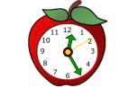  Look out for common wild and garden plants (including trees) and keep a record of what you spot. You could even make a tally chart! | Time  Make a leaflet about telling the time!  Make sure you include o’clock, half past and quarter to/quarter past.  How many minutes in an hour?  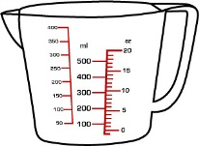  How many seconds in a minute?  How many hours in a day?
Being Healthy  Find out what our bodies need to be healthy show what you find out on a poster.  Think about why it is important to eat the right foods.  What kind of exercise would you recommend?  What is good hygiene and why is it important? | Make a boat  Design and make a boat that can float on water. What materials will you use?  Either bring it in to show us or take a photo of it in action!  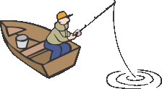 | Measuring  In maths we will be looking at capacity. Experiment with measuring millilitres, litres and temperatures.  Find things that you can measure these things with. Experiment with full, half full, nearly empty. See if you can read the measurements.  Show your findings through pictures and captions to explain your understanding.
Don’t forget to practice your reading at home along with reading and spelling the Year 2 words in your Reading Record! Remember to practice your phonics too!

