Designit  Michael Brennand-Wood is a famous British textile artist. Design your own Michael Brennand-Wood inspired object. Use fruit and vegetables as the ideas for your work. 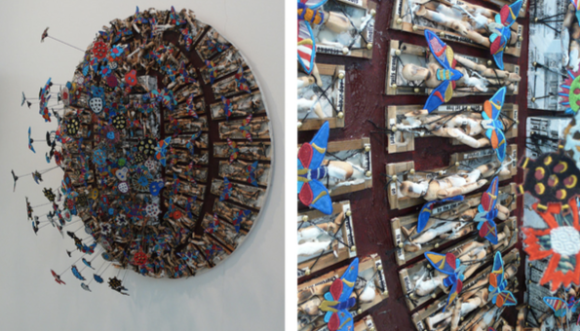  Skills –to learn about great artists, architects and designers in history. | 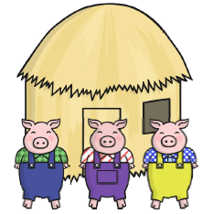  Branching Story  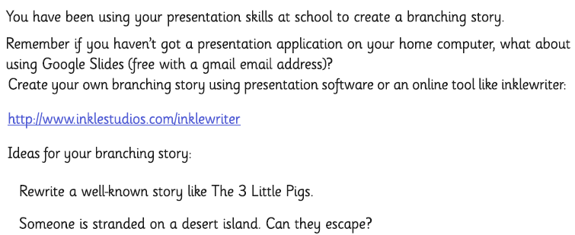  Skills – to increase their familiarity with a wide range of books including fairy tales. |  | Reviewit  Create a book review of a book that you would recommend to someone in the class. See examples below:  http://www.loxwoodschool.com/website/childrens_area/33060  Skills – to participate in discussions about books that are read to them and those that they can read for themselves. |  | Createit  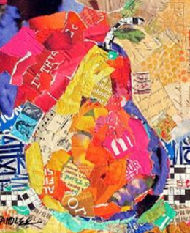  Research a famous collage artist. Then create a fruit of vegetable collage inspired by your chosen artist.  Skills - to learn about great artists, architects and designers in history. | Writeit  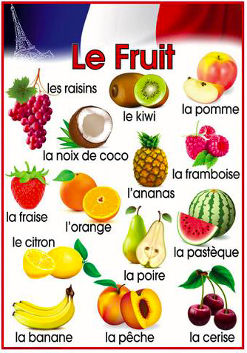  Can you remember how to talk about going shopping in French?  Design a poster to show the names of fruit you have learned the names of and research the names of others.  Skills – to describe people, places, things and actions orally and in writing.
Huntit  Find and name any 3-D shapes that you can see in your local environment. Write down the number of faces, edges and vertices, and the shapes of the 2-D faces.  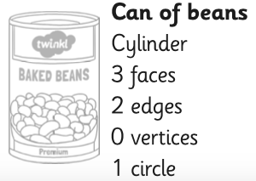  Skills - to recognise 3-D shapes in different orientations. |  | Summariseit  Create a storyboard to summarise a book you’ve read this year.  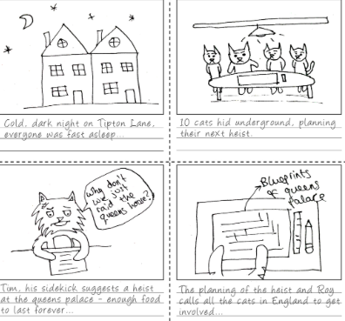  Skills – to identify main ideas drawn from more than one paragraph & summarise these. | Mapit  Show which countries the different plant explorers visited by marking their voyages on a world map. Can you use a different colour for each pant hunter? Draw sketches of the plants they found in the countries they are originally from.  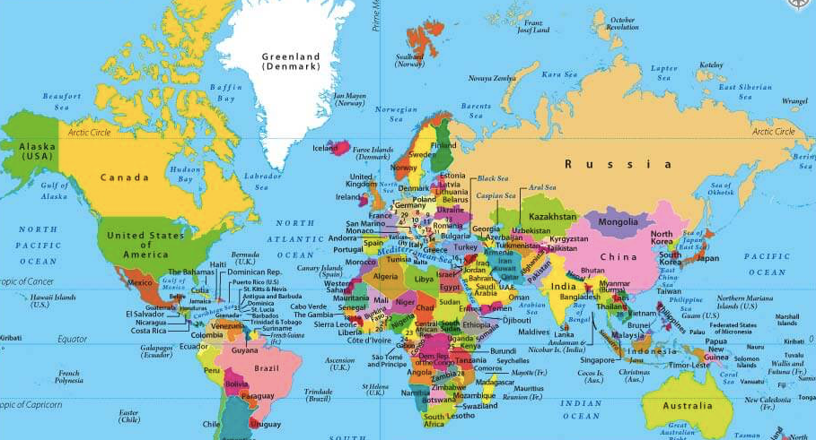  Skills – to locate the worlds countries, using maps. | Designit  Design a flag of your choice. When you’ve finished, see if you can label the angles (right-angle, obtuse and acute) and lines (parallel, perpendicular, vertical, horizontal etc.)  Skills – to identify angles, horizontal and vertical lines and pairs of perpendicular & parallel lines. |  | Researchit  Create a fact file for a famous plant hunter. Find out where they lived, where they went to school and which plants they collected.  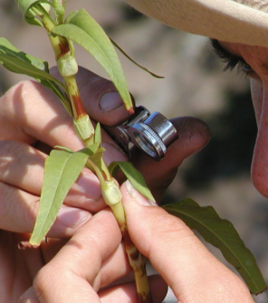  Skills – to use search technologies effectively.
Presentit  Choose 2 Sikh Gurus and compare them. How are they similar? How are they different?  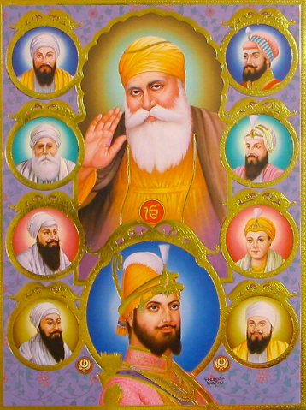  Skills – to understand that different religions have different beliefs. |  | Representit  Can you design and create a way to represent the stages of the life cycle? You could: use paper plates; make a poster; create a small book; create a presentation.  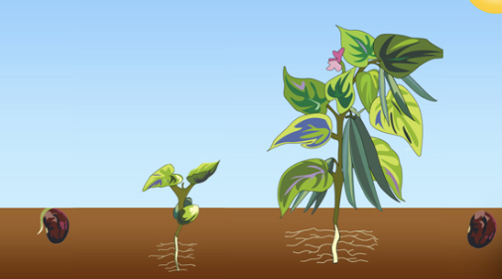  Skills – to report on findings, including oral and written explanations, displays or presentations. | Recordit  Can you record a weather forecast in French? You can make a title page and credits - La météo pour aujourd’hui est présentée par... [today’s weather is told by...] Filmé par... [filmed by...] Show the forecasts to a friend.  Skills – to describe people, places, things and actions orally and in writing. | Designit  Design your own garden. Identify the various features e.g. walls, grass, trees, ponds.  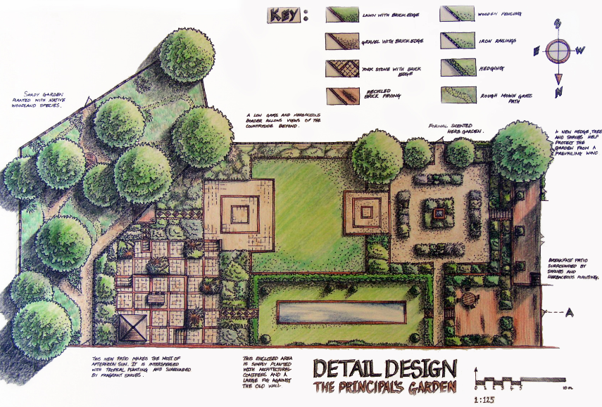  Skills – to use drawing to develop and share their ideas, experiences and imagination. |  | Reciteit  Having found a variety of shape poems, can you explain to class which is your favorite and why?  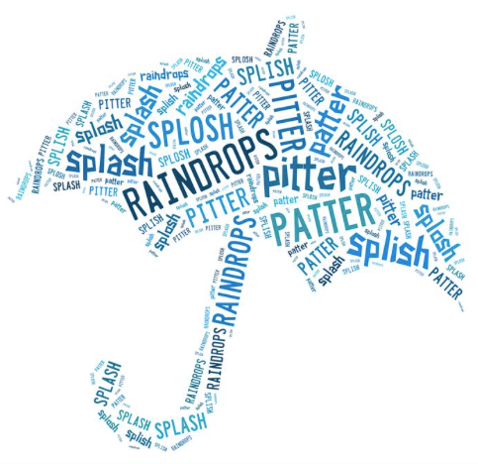  Skills – to recognise some different forms of poetry; to articulate and justify answers, arguments and opinions.
Suggested hand-in Dates: 1st May, 15th May, 5th June, and 19th June. Please try to choose a variety of coloured tasks.

