16th – 30th March 2020

**In Personal, Social and Emotional**

**Development we are learning to…**

Explain own knowledge and understanding of events.

Attends to and takes account of what others say.

Confident to speak to others about own needs, wants, interests and opinions.

Take turns in games.

Activities: talk about their learning, talk about their partner’s ideas. Learn a board game and follow the rules.

**In physical development we are**

**learning to….throw accurately**

Throwing and catching skills

Please provide school joggers for outdoor PE kit

Activity

PE with Mr Green on **Wednesday** – whole class

**On Tuesdays** afternoons half the class will continue to have a PE session with Premier Sports 17.03.20 with Malham & Brewhurst/24.03.20 Drungwick & Southlands, the finishing on 31.03.20 with Malham & Brewhurst.

**In Communication and Language we are**

**learning to…..**

maintain concentration, listen attentively in a range of situations, listen to stories from beginning to end & answer questions based on the story

extend our vocabulary, especially by grouping and naming, exploring the meaning and sound of new words.

Activities

Share both fiction and non-fiction books at home.

**3 week YE Plan**

**planner**

Don’t forget to tell us about how you celebrate Easter in your family. Do you have a tradition meal at Easter time? If you do not celebrate, tell us about a celebration which is important to your family. 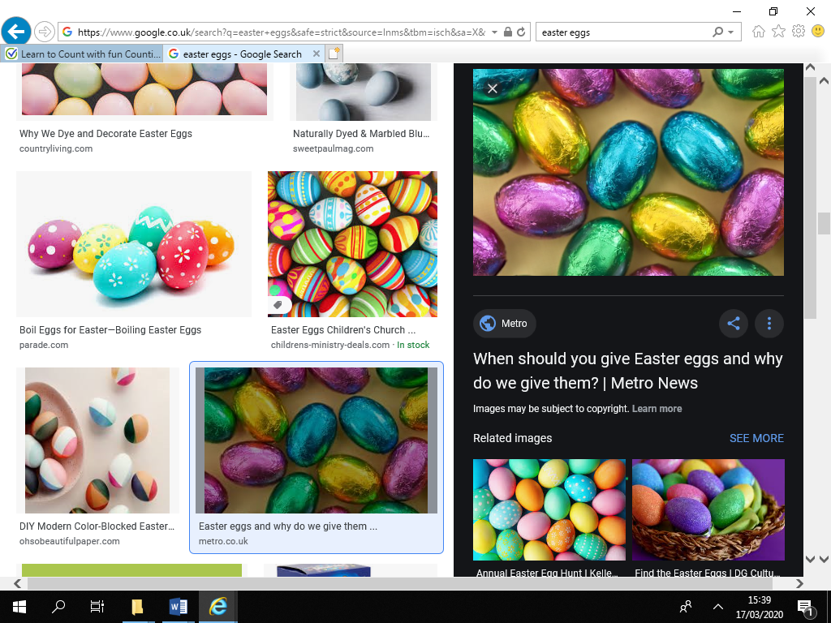

**In Creative Arts and Design we are learning to..**

Play high and low notes on a xylophone.

Build up a repertoire of familiar songs.

Activities

Music: we are now joining KS1 singing assembly.

We also follow the ‘Charanga’ Music Scheme - respond to different styles of music, keep the pulse, and about high and low notes,

**In Understanding the world we are learning..**

about mini-beasts and their environments

why animals are camouflaged

about caring for our world (and how humans can destroy the word). Why animals are extinct.

to compare mini-beasts (what they eat, where they live, how many legs they have, if they have wings etc)

Activities

Bug Hunt. Sharing stories and non-fiction books.

In Early Years we plan across the 7 areas of learning and

make links with our topic. We also follow the ideas and

interests generated by the children. In Reception

children spend time each day self-initiating, this is their

‘Learning time’. Adults will be observing, engaging and

moving their learning on during these times.

**In Literacy we will are learning to…**

If your child is beginning to orally blend/independently blend – Revision of RWI Set 1 phonemes for reading and writing.

Hear and record initial sound in words/dominant sounds

For children competent at Set 1 phonemes and independently blending to read and write words containing these phonemes, RWI Set 2 ou, oy. We will then focus on recalling these digraphs/trigraphs in ‘Quickwrite’ Sessions.

Tricky Word: he she

Activities

Daily phonics lessons RWI

Writing linked to topic.

**In Mathematics we are learning to…**

use familiar objects and common shapes to create pictures and build models (linked to EAD).

Begins to use mathematical names for ‘solid’ 3D shapes and ‘flat’ 2D shapes and use mathematical terms to describe them e.g. talk about how many sides and corners 2D/edges and vertices 3D.

Selects a particular named shape.

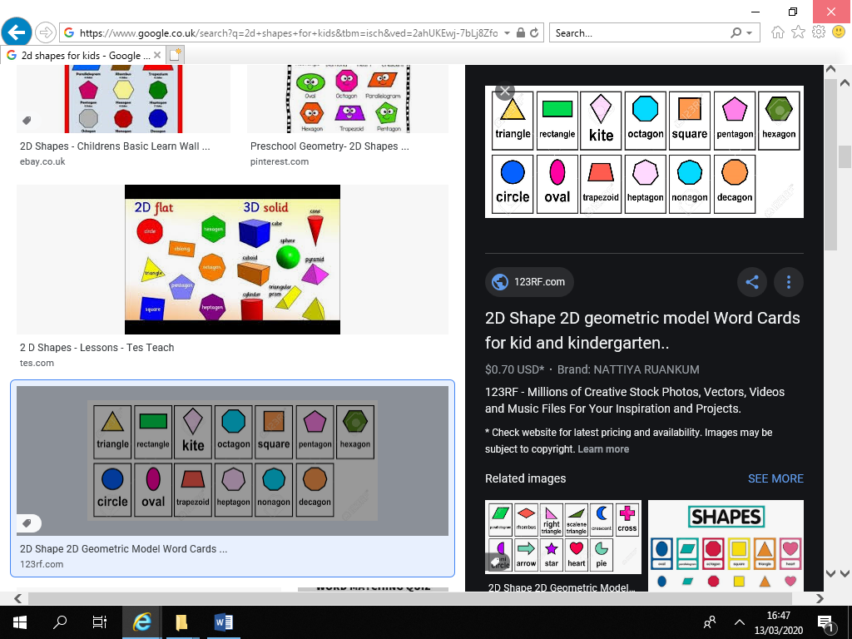

Ask me about…

