Loxwood School Art Gallery needs your help!
All you need to do is paint or draw a portrait of yourself in your classes’ given colour using different shades to make it look effective and email it to year2@loxwoodschool.com.
Pictures should all be A5 size (half of a normal sized piece of paper) and portrait rather than landscape, so that we can fit them all together! We will use them to make a ‘Virtual Rainbow Gallery’ to put on our school website and then eventually ask you to bring them into school, so that we can make an amazing whole school display like the one below!
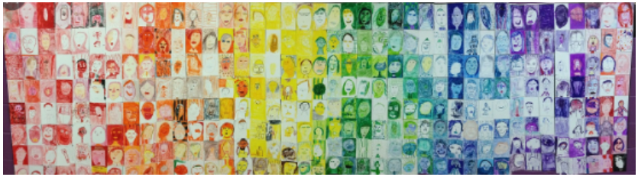Let’s create together!
Young Explorers – Red Year 1 – Orange Year 2 – Yellow Year 3 – Green
Year 4 – Blue Year 5 – Indigo Year 6 - Violet

