Y6 Independent Homework Grid  RAIDERS & TRADERS | Knowing | Understanding | Applying | Analysing | Creating | Evaluating
Verbal  I enjoy reading, writing and speaking | Write an information  text about the  Vikings. You could make a mini-book! | Write a story or saga set in Viking times. Use  historical facts to  make your story realistic. | Complete a fact page about a Viking long ship.  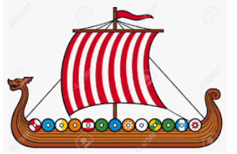 | Were the Vikings actually vicious? Write a  character description of a typical Viking.  Draw a picture or make a model too. | Design a ‘For Sale’ poster for a Viking longship. Explain its features. | What Anglo-Saxon words have survived in today’s spoken English? Do they have the same meaning?
Mathematical  I enjoy working with numbers and sequences | Complete a timeline showing the journey from the Celts to the Vikings. | Write some messages using Anglo-Saxon or Viking runes.  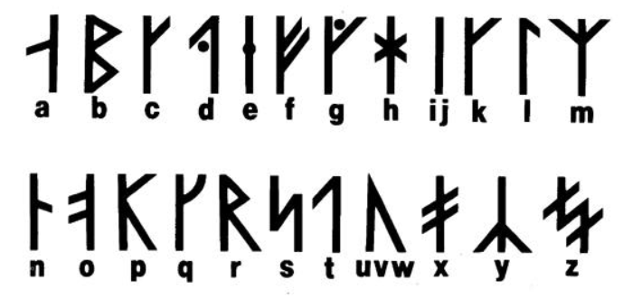 | Create a PowerPoint with an interactive timeline of important Viking events. | Use a map of the U.K and see how many  Anglo Saxon place names you can find. If they end in – ton, -ham, - burgh what did it mean? | Design a symmetrical shield or helmet.  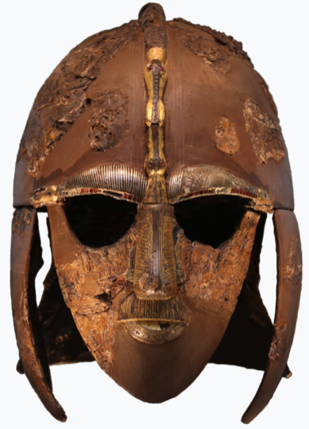 | Compare the Vikings and the Anglo Saxons. Who were the best invaders and settlers and why? You could make a Venn  diagram.
Visual/Spatial  I enjoy painting and drawing | What do you think Beowulf looked like? Paint a picture to portray his character. | Draw a diagram of an  Anglo-Saxon settlement. Why did they settle in Britain? | Using shading, draw a  portrait of a Viking  warrior concentrating  on their facial expressions. | Draw, paint or collage an Anglo-Saxon artefact  and analyse what it shows about Anglo-Saxon life. | Why were the Vikings victorious?  Make a replica Viking weapon and explain the reason for its design. | Recreate a section of the Bayeux Tapestry.  What evidence does it give us of the demise of the Anglo-Saxons?
Kinesthetic  I enjoy doing hands on activities, sports and dance | Make a piece of replica Viking jewellery.  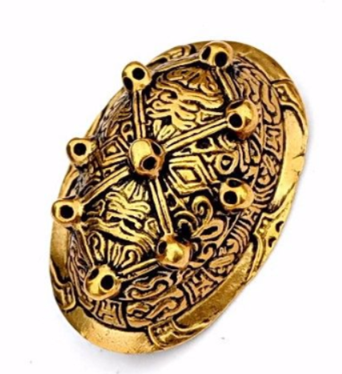 | Devise a movement sequence about Viking life e.g. rowing, raids, battles, village life. | Research Anglo Saxon or Viking food. Write a recipe. You could even have a go at cooking /baking something! | Lead the class in a Viking-inspired outdoor game. Keep it safe! | Make your own Viking house. You could use clay, card, dough or any other junk modelling objects to make it. | Make your own ‘archaeological dig model.’  Explain what the different items buried within it reveal about the Anglo-Saxons or Vikings.
Musical  I enjoy making and listening to music | Find out about Anglo-Saxon or Viking music. Present your findings to the class. | 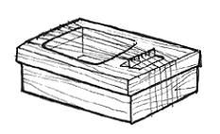  Make and decorate your own Anglo-Saxon lyre from a shoe box. | Vikings sang songs when they were happy.  Can you make a ‘Happy’ playlist to keep us happy in class? | Make a soundtrack to accompany images of the Northern Lights.  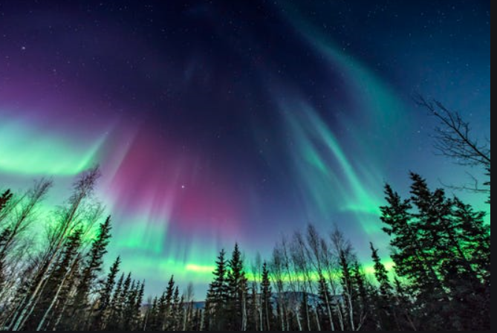 | Compose and record your  own song or tune about the Anglo-Saxons or the Vikings | Listen to some Nordic music. Play it to the class and explain how it makes you feel and/or what it tells us about the Vikings.  https://www.youtube.com/watch?v=pm7QtSXNcno
Interpersonal  I enjoy working with others | Draw and label a map/s to show where the Anglo-Saxons and Vikings came from. | Work with someone in your family or a friend to create your own Horrible Histories rap, showing what you know about the Anglo-Saxons. | Make a Viking or Anglo-Saxon inspired board game, such as a version of chess. | Write a mini playscript about a conversation between the monks at Lindisfarne as the Viking boat approaches. Perform it in class. | How did the Vikings travel to Britain? Make a model Viking longship. | What did the Anglo-Saxons believe? Make a presentation which shows the different evidence which answers this question. (BBC Bitesize will help.)
Intrapersonal  I enjoy working by myself | Write a job advertisement for a Viking warrior. | Where else did the  Vikings travel to?  Draw a Viking world  map. Why did they  go to these places? | Recipe for a raid  You will need:  20 angry Vikings, 1 longboat, 1 monastery … Write your own ‘Recipe for a Raid’. | Find a selection of Viking kenning poems. Which do you like best and why? Can you write your own? | Research what coins were like in Anglo-Saxon times. Design and make a coin with King Alfred on the front. | If you could meet any of the  famous people from the  Anglo Saxon or Viking  period, which would it be and  why?
Useful websites: Anglo-Saxons: https://www.bbc.co.uk/bitesize/topics/zxsbcdm
Vikings: https://www.bbc.co.uk/bitesize/topics/ztyr9j6 and https://www.dkfindout.com/uk/history/vikings/
Hand-in Dates: 15th Nov, 29th Nov, 13th Dec. Each task ideally to be taken from a different row and column.

