Out of this World!

Year 6 – Weeks beginning 14th & 21st October 2019

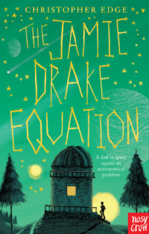
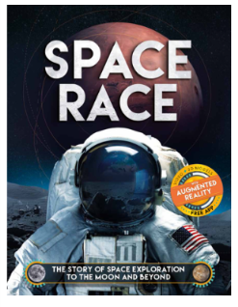
English
We are responding to Ben Hubbard’s writing challenge by creating a justified list of items to take on a hypothetical journey to Mars. We are learning to use bullet points and extend sentences with the effective use of conjunctions, relative clauses and semi-colons.

Grammar and spelling take a high priority. Spelling tests will be on Mondays and it is important to practise the weekly list throughout the week, recording this in the spelling homework book. At least three GOOD QUALITY sentences should be written using some of the week’s spellings.
Maths
We will be exploring methods for calculating with long multiplication – formal, grid and lattice as well as methods for long division. Our fluency skills will then be applied to solving word problems.
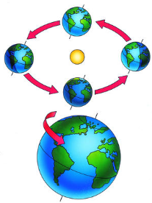
Weekly times tables squares will be completed every Thursday.
Topic
Our topic ‘Out of this World’ will enable us to learn about the ‘space race.’ We will explore the roles of the USA and USSR in this historical period and analyse the evidence in order to justify who won the race. In science we will learn how the movement of the Earth affects our seasons, how we get night and day and .
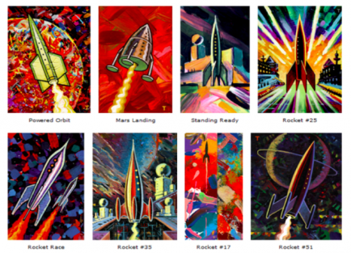
the phases of the moon. We will explore the space art of the artist Peter Thorpe

Forthcoming Events
Wednesday 20th November - House Matches

