7th, 14th & 21st October 2019

**In Communication and Language we are**

**learning to…..**

Listen attentively to books, talks and discussions.

Make comments and answer questions based on the text or events.

Talk in full sentences about story pictures

Activities

From 11th October - share Lilac story books at home (see info sheet in Learning Diary).

Daily class story and discussions.

**3 week YE Plan**

**planner**

**In Personal, Social and Emotional**

**Development we are learning to…**

Play a range of games and let others join our games (explain our game so others understand how to join in)

Share resources with adult support

To take turns in games with adult support

Saying STOP if we don’t like something

Understanding different things make us happy/sad e.g. some children don’t like being chased, others enjoy it.

Activities

Circle Time activities.

Sharing stories.

Using the timer to

take turns on the bikes

**In physical development we are**

**learning to….**

Understand why we need to drink water

Dress independently for the weather e.g. waterproofs

Please note we will be starting PE lessons after half term so PE kits need to be in school. Lessons are on Wednesdays. No tights please. Refer to kit list.

Activity

Design and make obstacle courses

Transport and use equipment safely e.g. moving tyres and planks, stacking crates,

Drink water during snack time, after lunch and encourage the children to self-select their water bottles.

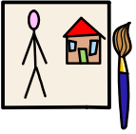

**In Understanding the world we are learning..**

to care for animals

about animals basic needs

to share news and events

Activities

Stories and non-fiction books about Pets

To talk about our pets

Visit from Stanley

Over half term,please fill in the use of technology questionnaire in LD’s

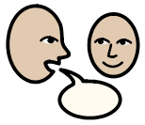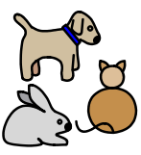

 



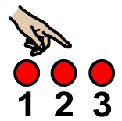

**Ask me about…**

**In Literacy we will are learning to…**

Give meaning to marks as they write and draw.

To notice and talk about signs around the classroom (linked to role play area)

To look at books independently in ERIC

To handle books carefully (placing them the correct way round in the bookcase)

To know information can be relayed in the form or print

To write in role (mark-making)

Activities

Role play

Listen to a range of texts

**In Mathematics we are learning to…count accurately**

Understand not only objects, but anything can be counted, including steps, claps or jumps.

Counts actions or objects which cannot be moved

Count up to 3 or 4 objects by saying one number name for each item

Count objects to 10 and beginning to count objects beyond 10

Have strategies for ensuring their counting is accurate e.g. starting again when they have lost their place, placing objects in lines, looking for the rows of objects when counting things that cannot be moved.

**In Creative Arts and Design we are learning to..**

Use a range of media, such as music, dance, role-play, paint and other materials to capture experiences

Activities

Self-selection painting easel

Cutting and sticking

**Christmas Cards**

**designs**

In Early Years we plan across the 7 areas of learning and

make links with our topic. We also follow the ideas and

interests generated by the children. In Reception

children spend time each day self-initiating, this is their

‘Learning time’. Adults will be observing, engaging and

moving their learning on during these times.