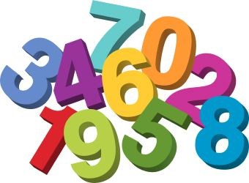

**Mathematics – Specific Area**

Rote counting – forewords/backwards

Matching numeral and quantity

Counting - knowing the last number reached tells

us how many there are in total

Problem-solving activities including an introduction

to numicon. Show ‘finger numbers’ up to 5 initially.

Experiment with marks and symbols as well as numerals

Comparing 2 groups of objects (greater/fewer/more/less)

Sorting 2D and 3D shapes and describing properties e.g. sides, flat, round etc

**Expressive Arts and Design – Specific Area**

Role –play (acting out real life scenarios or stories)

Make imaginative and complex ‘small worlds’ with blocks/construction kits e.g. a city with buildings and parks

Colour mixing

Free painting with increasing complexity and detail e.g. a face with a circle including eyes, nose, mouth and hair.

Junk modelling – joining materials and exploring textures

Play instruments with increasing control to express their feelings and ideas.

Remember and

sing entire songs.

**Personal Social and Emotional Development – Prime Area**

Managing basic hygiene and personal needs

Following the school rules and routines. Keeping safe.

Learning about feelings, sharing, building self-esteem (what I am good at/

what makes me special/overcoming challenges/solving problems).

**This Is Me!**

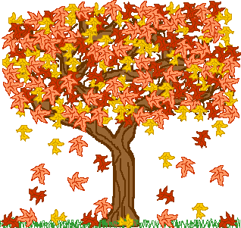

**Communication & Language – Prime Area**

Conversational skills – sharing ideas, listening to others, responding appropriately, Talk Partner Skills

Good listening and why it is important to listen

Opportunities for children to talk to peers and adults on a one-to-one, small group and whole class basis. Use longer sentences and continue conversations. Use talk to organise themselves and their play.

Enjoy listening to longer stories and remember much of what happens.

Begin to establish a repertoire of rhymes, songs and favourite stories.

Use a wider range of vocabulary.

**Physical Development – Prime Area**

Develop movement; balancing, skipping, hopping, jumping, climbing, crawling, riding (scooters and trikes) and balls skills

Using and moving equipment appropriately and safely

Collaborating with others to manage large items.

Choose the right resources to carry out their own plan

Learn about healthy choices e.g. food, drink, activity

and toothbrushing.

PE – starts after half term with Mr Green

Manage changing including turning clothes the correct

way around ready to put on again.

We also follow the ideas and interests generated by the children. Adults will be observing, engaging and moving their learning on during these times.

**Literacy – Specific Area**

Understand key concepts about print including the names of

different parts of a book

Spot and suggest rhymes

Clap syllables in a word

Recognise words with the same initial sound

Make up stories

Retell familiar tales using story language

Mark-Making in play e.g. writing a menu, list, instructions

Daily phonics (Read Write Inc.) including how to write letters

Write some or all of their name

**Understanding the World – Specific Area**

My special people –my family and friends

Celebrations and special times – recognising people have different beliefs and celebrate in different ways e.g. birthdays, Christmas.

Where I live and places I have visited (recognising similarities and differences)

People who help us – different job roles and the

impact on our lives (staying safe)

My body – body parts (staying healthy)

Changing seasons – Autumn leaves & weather.

Exploring ice (melting & freezing) – weather

dependent (this may be covered next term)