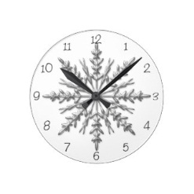
Up to the minute……14.2.19

Dear Parents and Carers,

What a refreshing change it has been to see the sunshine today and just in time for half term! All of the staff would like to wish our families a very happy half term, we hope you have some time to recharge. We are looking forward to seeing you all re-energized for the second half of the spring term which will be filled with more learning adventures.

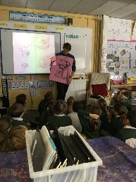
William Grill Visit
On Monday years 3 & 4 were very lucky to be visited by William Grill, the author of Shackleton’s Journey. The children had a wonderful day talking to him, looking at his books, asking lots of questions and were lucky enough to be able to purchase a signed copy of his book. The children really enjoyed looking at his original sketches and ideas as well as a drawing workshop where the children were inspired by his illustrations to create their own work.

New Infant & Reception Sports Club
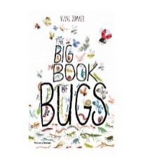
There are still spaces on our new multisport club for Reception, Year 1 and Year 2 starting on Monday 25th February. The club will be run by Dave Ruff, who is fully qualified and has years of experience running these clubs. If you would like your child to attend, please see the school office.

Wish List
This week Year 4 would like to thank you for purchasing the wonderful book Big Book of bugs, it has been received and the children look forward to using it.

Year 2 Violins
Today has been very exciting for Year 2 as we have begun our stretch of violin lessons with Miss Hester from West Sussex Music Service. The children were so enthusiastic and showed wonderful promise on their first session! You will be able to share in our achievements when we put on a concert for our families later in the term. We will inform you of the concert date when it has been confirmed.

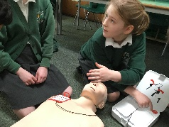
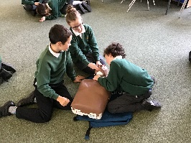
Mini Medics
This week, Year 5 and 6 have each received a morning of 'Min-Medics' training. They have all learned about essential first aid, and how to cope in an emergency situation. They know how to contact the emergency services, respond to an unconscious patient and practised using a real defibrillator. They also practised bandaging each other. The children all behaved responsibly and enjoyed the interactive nature of the session. We are very grateful to the PTA for funding this very important life skill.

Free 2 Be Club
We are pleased to be able to offer a new after school club available to Years 3 – 6. “NURTURE YOUR SELF CONFIDENCE AND SELF BELIEF, DEVELOP HEALTHY FRIENDSHIPS AND DEAL WITH EMOTIONS - COPING STRATEGIES TO DEVELOP A GROWTH MINDSET” This club takes place in 4 week blocks. Please see the attached flyer for all information and book directly with Lisa Nugent – Free2Be.

SATs Meeting
There will be a SATs meeting for Year 6 parents on Tuesday 26th February at 5.30 in the Year 6 class room.

Athlete Visit
On Wednesday 13th March Ezekiel Ewulo, Long jump and relay champion, will be visiting the Juniors. They will be doing sport circuits with him and have the chance to ask him lots of questions. Your child has come home with a sponsor form. Please ask family and friends to sponsor your child, there is a prize for the most sponsorship raised! All the money will go to our school.
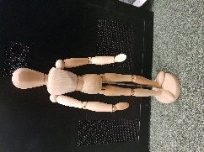
Wooden Manikins
We have some wooden manikins for sale, they are great for budding artists and are only £3.00 each!

Cranleigh Rugy Club
On Monday players from Cranleigh Rugy Club came to our assembly to tell us about their club. They take children from 5 to 11 years. For more information please cotact Marcus on 07900884431.

Kind regards,
Ms Kitson

Did you know……………..

During the Easter holidays, the music room/SEN room will be converted into a brand new library, which has been partly funded by the PTA!

Congratulations to the children who received a celebration certificate.
Young Explorers: Esabella for Contribution and Lilly-May for Enthusiasm
Oak Class: Annabel for Ambition and Alice for Aspiration
Willow Class: Lillie for Effort and Happiness and Lily-May for Explanation
Rowan Class:
Sycamore Class: Rachel for Determination, Lucas for Friendship and Lola for Positivity
Mulberry Class: Charlotte for Enthusiasm and Emma for Determination
Chestnut Class: Mia for Kindness and Bertie for Encouragement

The winning house this week is:
Drungwick

General dates
Bikeability - Week beginning 25th February -Year 6 * change of date
Pancake Races - 5th March 2.30pm Parents welcome
Bedtime Story Day Book Week - 8th March Come dressed in your PJs for bedtime stories.
Parent Consultations - 12th March 3.30pm
Parent Consultations -13th March 5.00pm
Athlete Visit - 13th March – Juniors only * change of date
Hampton Court Palace trip - 19th March – Years 5 & 6
Class Photos - tbc
Come and See - 2nd April 3.30pm Parents welcome
End of Term Assembly - 5th April 2.30pm Parents welcome

INSET days for this Academic Year
Friday 15th February 2019
Monday 22nd July 2019
Tuesday 23rd July 2019

Half Term / End of Term Holidays 2018/19
Monday 18th February - Friday 22nd February 2019
Monday 8th April - Monday 22nd April 2019
Monday 27th May - Friday 31st May 2019
Last day of term - Friday 19th July 2019

Forest School Dates
On your child’s Forest School day they can come to school in their Forest School clothing for the whole day, please ensure they are wearing long sleeved tops and trousers – even if the weather is warmer. They will also need suitable footwear, e.g. wellies and a rain coat. If you are able to help on Forest School dates, please see the school office.

Wednesday 27th Feb Young Explorers
Wednesday 6th March Year 1
Wednesday 13th March Year 2
Wednesday 20 March Year 3
Wednesday 27th March Year 5
Wednesday 3rd April Year 6

Year 4 TBC

