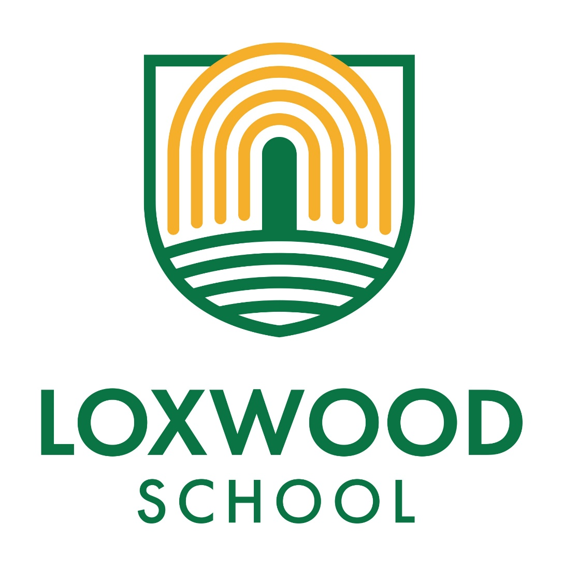
A Parent’s Guide to Accelerated Reader
September 2020

Accelerated Reader
Children in school use the Accelerated Reader (AR) program. It has proved to be a very effective system for motivating children and ensuring good progress in reading. This guide is jam-packed full of questions and answers about AR. If you have additional questions, please feel free to contact your child’s teacher.
What is Accelerated Reader?
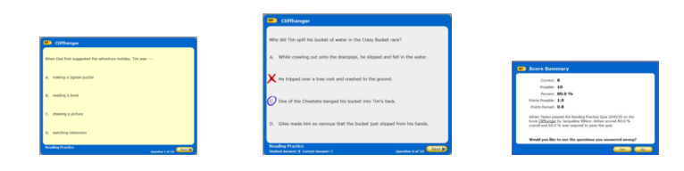
AR is a computer program that helps teachers manage and monitor children’s independent reading practice. Your child picks a book at his/her own level and reads it at his/her own pace. When finished, your child takes a short quiz on the computer – passing the quiz is an indication that your child has understood what has been read. The absolute key here is the understanding – your child may be able to physically read the words of almost any book out loud but the quizzes test the understanding/comprehension of the chosen text. AR gives both teachers and children feedback based on the quiz results which the teacher then uses to help the child set targets. AR will not take the place of Guided Reading. Specific skills for decoding and comprehension will be taught by your child’s teacher, but AR will help to ensure that the children’s independent reading practice is appropriate and effective.

Children using AR have a free choice of the books they read (within their given range), rather than having one assigned to them. This makes reading a much more enjoyable experience as they feel in control and can choose books that are interesting to them.
Teachers and teaching assistants will be on hand to help your child choose books that are at an appropriate reading level. These will be challenging without being frustrating and will also be at a level at which your child can pass the quiz and experience success.
If your child does not do well at the quiz, the teacher may assist him/her by:
- Helping choose another book that is more appropriate
- Asking more probing questions as your child reads and before he/she takes a quiz
- Pairing your child with another pupil or even having the book read to your child.
In most cases, children really enjoy taking the quizzes. Since they are reading books at their own interest and reading levels, they are likely to be successful. This is satisfying for most children. Best of all, they learn and grow at their own pace.
How does the school determine my child’s reading level?
Teachers determine your child’s reading level in three ways: a STAR Reading test, a reading age estimation from previous assessment scores, or by using his/her best professional judgement based on his/her knowledge of the child.
What is a STAR Reading test?
STAR Reading is a computer based reading assessment program that uses computer adaptive technology. The child is presented with questions, which require a multiple choice answer. Questions continually adapt to your child’s responses. If the child’s response is correct, the difficulty level is increased. If a child cannot answer a question or answers incorrectly, the difficulty level is reduced. The whole test takes approximately 10 minutes and is never an ordeal. A report gives an ‘ATOS’ reading level for each child, which alongside all the assessment information that we already have, helps the teachers to determine an appropriate reading range for your child.
What is a Book Level?
Books are levelled using a nationally recognised readability formula and represent the difficulty of the text. The levelling criteria covers factors such as vocabulary, average word length, average sentence length, grammatical complexity etc. – not how long the book is or how many pictures it contains!
Normally, books are chosen between a range of levels (the child’s Zone of Proximinal Development - ZPD) recommended for each pupil by STAR Reading.
The books are organised on shelves according to level to make it easier for children to choose an appropriate book. In each Team there are a selection of AR books based on ZPD levels of children in class.
What is a Zone of Proximinal Development (ZPD)?
In independent literature-based reading, ZPD is the range of books that will challenge a child without causing frustration or loss of motivation. Your child will be given a ZPD range after taking a STAR Reading test or teachers will use their best professional judgement to determine a ZPD. It is important for children to read independently with a high degree of comprehension and within his/her ZPD. During the year, as your child progresses in their reading, we would expect this range to change to reflect the improvements that they are making.
Is it ok for my child to read outside of their ZPD?
Just because a child can read the words in a book does not mean the content is appropriate. Many of us could ‘read’ a journal on Astrophysics but few of us could claim to ‘understand’ or ‘comprehend’ it. This is an important consideration when choosing books with children. Some books have complicated vocabulary, but simple storylines; others might have far simpler vocabulary, but more complex storylines.
When choosing a book, it is essential that the child is interested in the book, will enjoy reading it and feel success in having finished it and understood it. Within AR, the Interest Level of a book is based on content – a book’s themes and ideas – and indicates for which age group a book is appropriate. The chart below shows which years fall into each Interest Level.
Interest Level Year Level
LY – Lower Years
Key Stage 1

MY – Middle Years
Key Stage 2

In many cases a book’s Interest Level coordinates with its book level. Many books however, have a low book level but are appropriate for Upper Years and vice versa.
What are Points?
Every book that has an AR Reading Practice Quiz is given a points value. AR points are based on the difficulty of the book and the length of the book (number of words).
The point value of our books is indicated on a label inside the book cover
Children earn points on a pro-rata basis depending on how well they do on the Reading Practice Quiz. For example, a pupil who takes a 5-question quiz on a book worth 1 point will earn 1 point for 5 correct answers (100%), 0.8 points for 4 correct answers (80%) and so on.
A pupil who reads a book worth 5 points and takes a 10-question quiz will earn 5 points for 10 correct answers (100%), 4.5 points for 9 correct answers (90%), etc. A child needs to pass a quiz with a score of 60% or higher to earn any points.
How are Accelerated Reader point targets set?
Teachers set a target of a number of points to achieve in a half term. Achieving a half term’s target will be rewarded as the teacher’s look to develop their own in-class systems, alongside the children’s own ideas! The target is designed to be motivational and to ensure enough reading practice is happening to guarantee progress.
My child is not a strong reader. Can he/she still use Accelerated Reader?
Accelerated Reader helps all children become better readers, from pupils with special needs to those who are gifted and talented. When children read books at their appropriate level, they experience success, furthermore teachers work with children to set appropriate targets based on each child’s reading level.
How many AR Quizzes are there?
There are over 12,000 quizzes available and more become available each and every month. Not all books have an available quiz but the vast majority of popular authors/books are covered, together with traditional favourites and many more obscure titles! The school has an extensive book stock. West Sussex library services also lend us AR labelled books that are changed every term.
How will I know if a book has an AR Quiz?
There are several ways of achieving this. Your child can bring a book into school, log in to the system and search for the quiz. However, a fantastic service is the AR BookFinder, available at www.arbookfind.co.uk and through Home Connect which allows you to conduct a search of all available books with AR quizzes.
How can I help my child find books that are interesting to them?
Visit www.arbookfind.co.uk and click on Advanced Search. By conducting an advanced search, you will be able to generate book lists that contain titles based on the criteria you enter such as Book Level, Topic, Interest Level and Fiction/Non Fiction, etc.
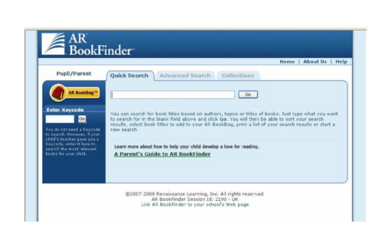
If the books are at your child’s AR reading level, then they may be able to access the book from home, from school stock or from the school or village library. Once they have enjoyed the book, they can complete the relevant quiz in school! You, as parents/carers, can follow their progress too…

How will I know how my child is doing?
The Renaissance Place Home Connect system, which can be accessed from any web-enabled computer, will allow parents to keep track of their children’s progress. You can access Home Connect through the link on the school website. You will need your child’s AR username and password to do so. Once in the program, you can view your child’s progress towards targets, points and books read. You can also access AR BookFinder to search for titles of interest. You can only access information about your child.
https://www.renaissance.com/products/practice/home-connect/
