[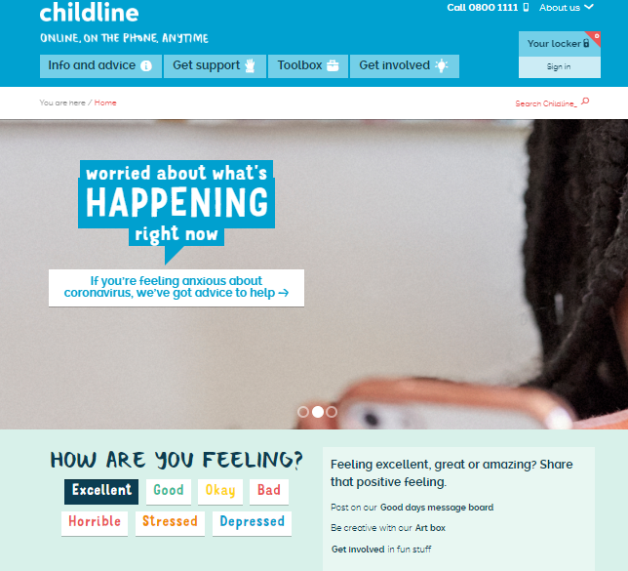](https://www.childline.org.uk/)

<https://www.childline.org.uk/>