16th and 23rd November 2020

**In Personal, Social and Emotional**

**Development we are learning to…**

Understand how to treat others

Play co-operatively as part of a group to develop and act out a narrative.

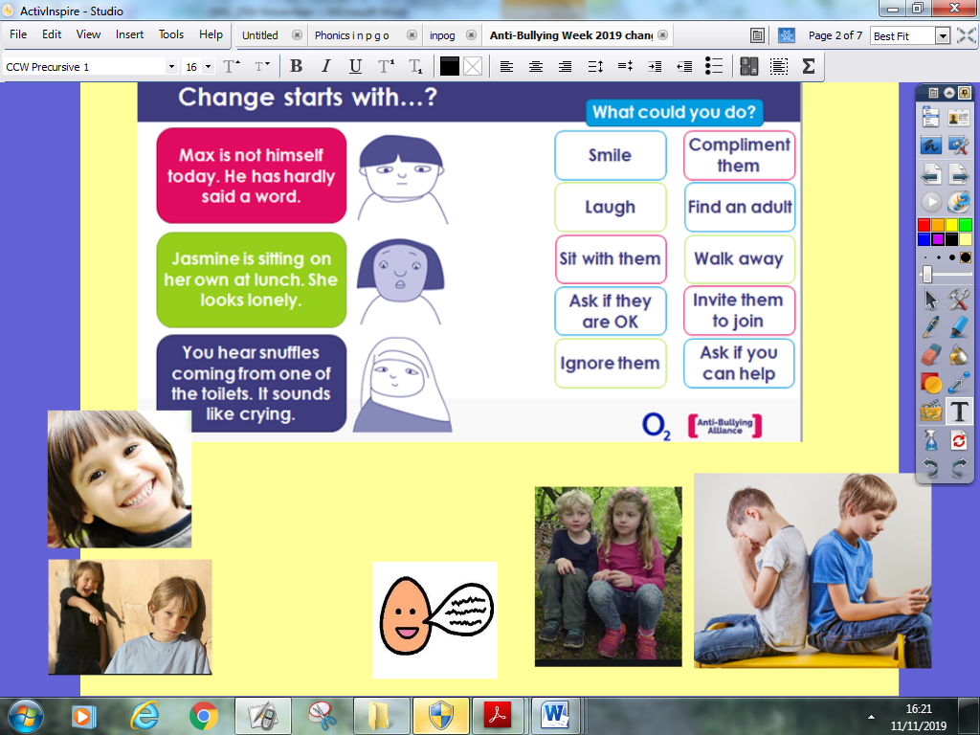 



Activities

Anti-Bullying Week activities – remember Odd Sock Day on Friday 20th November.



**In Communication and**

**Language we are**

**learning to…..**

demonstrate

appropriate conventions:

turn-taking, waiting until

someone else has finished,

listening to others (not to

interrupt)

**In physical development we are**

**learning to….**

change into PE kit (PE shirt, PE shorts, joggers, jumper or cardigan, plimsolls, socks – gloves if cold)

understand what happens to our bodies when we exercise

move in different ways e.g. marching, skipping

Activity

Session run by Mr Green on Wednesday morning (you may want to send your child to school in joggers but bring spare joggers/school trousers in case of accidents)

**2 week YE Plan**

**planner**

**In Mathematics we are learning to**…

Recite numbers in order to 10

Recognise numerals to 5/10

To order numerals to 5/10 Some children will progress to ..say one more than a given number



What rhymes with…? Can you think of any more?

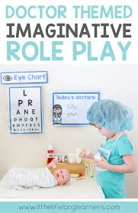

Dressing up - Monday 16th November





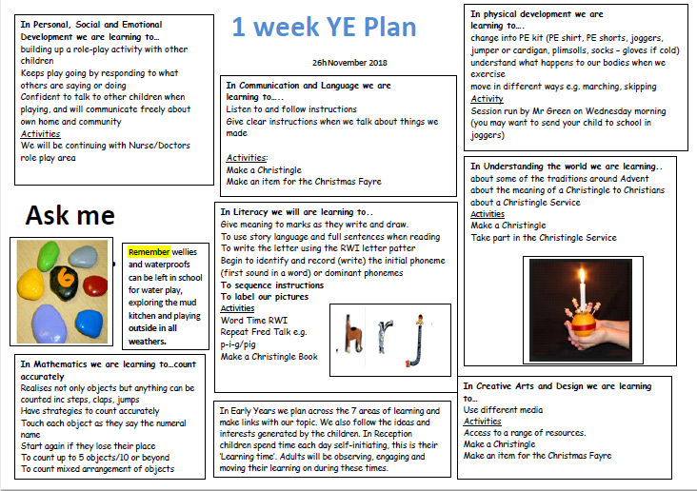

[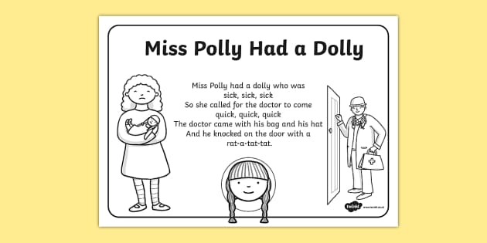](https://www.google.co.uk/url?sa=i&url=https%3A%2F%2Fwww.twinkl.co.in%2Fresource%2Ft-t-18442-miss-polly-had-a-dolly-colouring-in-sheet&psig=AOvVaw05t32NNbFI7-WhXB3LiJ1v&ust=1605096685314000&source=images&cd=vfe&ved=0CAIQjRxqFwoTCJCzgqD59-wCFQAAAAAdAAAAABAE)

**In Understanding the world we are learning..**

To take part in a science experiment linked to Humpty Dumpty

**…**about the role of a doctor or nurse in caring for people

Activities

Role play linked to the rhyme Miss Polly had a Dolly

Share non-fiction books about doctors and nurses

Science Experiment

**Ask me about…**

**In Literacy we will are learning**

**to..**

**..recognise rhyming words**

**..continue a rhyming string**

Give meaning to marks as they

write and draw.

To learn to recall the phoneme of the day taught in Read, Write Inc lessons (see Sound Book)

To write the letter using the RWI letter patter – see class page link

To look at books independently

Activities

Take part in phonics lessons

Repeat Fred Talk e.g. c-o-t,

f-e-ll, r-e-d

Listen to a range of texts

**In Creative Arts and Design we are learning..**

To take part in role play activities

To introduce a storyline

or narrative into

their play.

Play alongside others

engaged in the same

theme

In Early Years we plan across the 7 areas of learning and

make links with our topic. We also follow the ideas and

interests generated by the children. In Reception

children spend time each day self-initiating, this is their

‘Learning time’. Adults will be observing, engaging and

moving their learning on during these times.