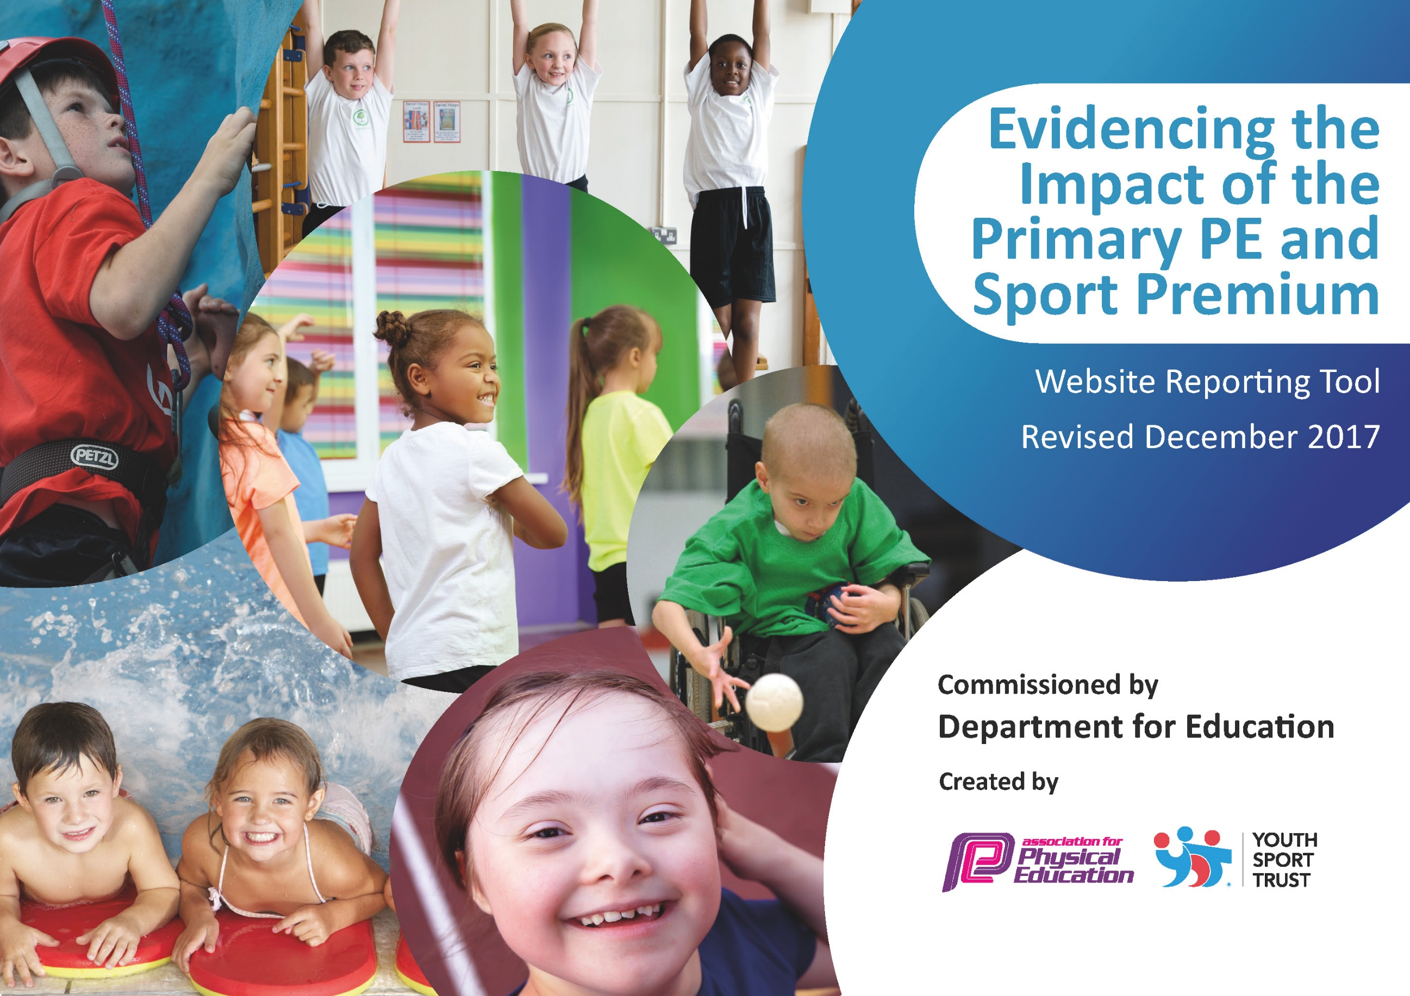

Schools must use the funding to make additional and sustainable improvements to the quality of PE and sport they offer. This means that you should use the Primary PE and Sport Premium to:

- develop or add to the PE and sport activities that your school already offers
- build capacity and capability within the school to ensure that improvements made now will benefit pupils joining the school in future years

Please visit gov.uk for the revised DfE guidance including the 5 key indicators across which schools should demonstrate an improvement. This document will help you to review your provision and to report your spend. DfE encourages schools to use this template as an effective way of meeting the reporting requirements of the Primary PE and Sport Premium.

We recommend you start by reflecting on the impact of current provision and reviewing the previous spend.
Under the Ofsted Schools Inspection Framework, inspectors will assess how effectively leaders use
the Primary PE and Sport Premium and measure its impact on outcomes for pupils, and how effectively governors hold them to account
for this.

Schools are required to publish details of how they spend this funding as well as on the impact it has on pupils’ PE
and sport participation and attainment.
We recommend regularly updating the table and
publishing it on your website as evidence
of your ongoing review into how you are using the money
to secure maximum, sustainable impact. To see an example of how to complete the table please click HERE.

Support for review and reflection - considering the 5 key indicators from DfE, what development needs are a priority for your setting and your students now and why? Use the space below to reflect on previous spend, identify current need and priorities for the future.

Key achievements to date: | Areas for further improvement and baseline evidence of need:
- Provided all KS2 students with 2 hours of physical education p/w (within the curriculum only); and have extracurricular provision in addition to this;  - Engaged at least 77% of students in extracurricular sporting activity every week (27% more than last year).  - Offered talented young sports people specific support to help them to develop their sporting potential.  - Engaged at least 40% of students in leading, managing and officiating School Games activity (25% more than last year).  - 4 pairs of children qualified for the Fairways to Horsham Golf Competition  - A year 6 boy finished 2nd overall at the Horsham District School Cross Country Festival and was then selected to represent the school at the County Finals.  - L-KS2 (Year 3 and 4) won the Horsham District Sports Athletics competition for the first time.  - The L-KS2 Football Team that entered the Horsham District Football Tournament were unbeaten in their first meeting in October. | - A wider range of opportunities for Year 3 and 4. A lot of the competitions we entered last year were aimed at Y5 &6.  - Improving the quality of independent play with a particular focus on balance, strength and coordination.  - A subsidised after-school club for infants to encourage regular physical activity.

Meeting national curriculum requirements for swimming and water safety | Please complete all of the below:
What percentage of your current Year 6 cohort swim competently, confidently and proficiently over a distance of at least 25 metres? | 100 %
What percentage of your current Year 6 cohort use a range of strokes effectively [for example, front crawl, backstroke and breaststroke]? | 95.6%
What percentage of your current Year 6 cohort perform safe self-rescue in different water-based situations? | 82.6%
Schools can choose to use the Primary PE and Sport Premium to provide additional provision for swimming but this must be for activity over and above the national curriculum requirements. Have you used it in this way? | Yes/No

Action Plan and Budget Tracking
Capture your intended annual spend against the 5 key indicators. Clarify the success criteria and evidence of impact that you intend to measure to evaluate for students today and for the future.

Academic Year: 2018/19 |  | Total fund allocated: £17440 | Date Updated: 17/07/2019
Key indicator 1: The engagement of all pupils in regular physical activity – Chief Medical Officer guidelines recommend that primary school children undertake at least 30 minutes of physical activity a day in school |  |  |  |  |  |  | Percentage of total allocation:
 |  |  |  |  |  |  | 34%
School focus with clarity on intended impact on pupils: |  | Actions to achieve: | Funding allocated: |  | Evidence and impact: |  | Sustainability and suggested next steps:
All children to be engaged in physical activity daily.  Children to have access to a range of sports which suit their interest and physical needs.  Raise awareness of importance of kick-starting healthy active lifestyles through Healthy Schools Week.  Improving the quality of independent play with a particular focus on balance, strength and coordination. |  | Update the school PE policy  Audit whole-school planning to ensure: evidences progression of P.E. skills across the school & sport mapping to accommodate fixtures ensuring suitable coaching prior to competitions.  Maintain the level of PE teaching within the school.  Children will be more aware of the importance of healthy, active lifestyles.  Replace playtime equipment inc. trimtrail. | £5927.14 |  | Planning and timetabling shows a range of sporting activities offered to all pupils.  Planning shows competition dates.  Pupil evidence including pupil voice on the website. |  | - All KS2 children have been provided with 2 hours of physical education p/w (within the curriculum only); and have extracurricular provision in addition to this.  - Funding has been used raise attainment in primary school swimming to meet requirements of the national curriculum before the end of key stage 2.  New play time equipment has helped embed physical activity into the school day through active playgrounds and active teaching.  Ensured children were being taught the skills and sports prior to competitions.  This was successful although the dates change each year so this will continue.
Key indicator 2: The profile of PE and sport being raised across the school as a tool for whole school improvement |  |  |  |  |  |  | Percentage of total allocation:
 |  |  |  |  |  |  | 12%
School focus with clarity on intended impact on pupils: |  | Actions to achieve: | Funding allocated: |  | Evidence and impact: |  | Sustainability and suggested next steps:
Friday assembly every week ensuring the whole school is aware of the importance of PE and Sport and to encourage all pupils to aspire to be involved.  School games promoted to the parents and local community fortnightly.  Developing links with Governors:  Discuss action plan, identify opportunities to monitor PE & report to Governors about PE and School Sport Premium.  Developing young Sports leaders within our school which allows us to introduce and extend competitive opportunities in our own school. |  | Achievements celebrated in assembly (match results and notable achievements in lessons etc.)  Regular updates sent to parents via Up to the Minute and the school website.  Governor will have a clear understanding of PE within the school, be aware of areas for development including changes identified through the year & will be aware of how the funding has been spent.  Train Year 5s in Summer term so they can take over next year.  Encourage Sports Leaders to be used to organise Level 1 competitions. | £2124.47 |  | Monitoring by the Governor is included in the whole-school monitoring plan.  Provided opportunities for children to work as a team in sports they might not always get a chance to try. Children have developed sportsmanship skills and collaboration.
Key indicator 3: Increased confidence, knowledge and skills of all staff in teaching PE and sport |  |  |  |  |  | Percentage of total allocation:
 |  |  |  |  |  | 19%
School focus with clarity on intended  impact on pupils: | Actions to achieve: |  |  | Funding  allocated: | Evidence and impact: | Sustainability and suggested  next steps:
Up-skilling staff to improve progress and achievement of all pupils.  Sports coaches to support school sport (Mr Green, Fairways to Horsham & Alternative Sports Festival).  Coordinate staff members to attend Weald Family CPD. | Undertake all PL which is offered through the sports partnership/LA/  National Associations (afPE & YST)/ NGBs/ Awarding Organisations with an aim to get more staff up-skilled and involved.  Surveys for staff.  Identify the local centres who are running these courses & ensure all identified staff are enrolled. Establish dates when cover is required and appoint cover staff. |  |  | £3289.00 | Staff meetings  Locality staff meetings  Discussions with staff. | Team teaching with Mr Green (a specialist PE teacher) has increased the quality of teaching and learning. He has also organised activities at lunch time and provided various after-school clubs. In coordination with the PE coordinator, he has supported the implementation of the “Learning to Lead’ initiative throughout the PE curriculum.  Mr Green to continue working with the school in a similar capacity, ensuring he is covering different sports.
Key indicator 4: Broader experience of a range of sports and activities offered to all pupils |  |  |  |  |  | Percentage of total allocation:
 |  |  |  |  |  | 7%
School focus with clarity on intended  impact on pupils: | Actions to achieve: |  |  | Funding  allocated: | Evidence and impact: | Sustainability and suggested  next steps:
Additional achievements:  Continue to offer a wider range of activities both within and outside the curriculum in order to get more pupils involved.  Focus particularly on those pupils who do not take up additional PE and Sport opportunities.  Healthy Schools Week promoting different sports that child may not have experienced previously.  Maintain the wide range of clubs on offer to the children.  Forest School  Residential | Ensure there are subsidised opportunities for all children to attend after-school sports clubs.  Arrange a pupil survey to ascertain what pupils would like.  Involve external coaches to work with staff in clubs. |  |  | £1237.00 |  | Introduce new sports, dance or other activities to encourage more pupils to take up sport and physical activities.  Supported and involved the least active children (using school representation & clubs lists) by providing targeted activities, and running or extending school sports.
Key indicator 5: Increased participation in competitive sport |  |  |  |  |  | Percentage of total allocation:
 |  |  |  |  |  | 8%
School focus with clarity on intended  impact on pupils: | Actions to achieve: |  |  | Funding  allocated: | Evidence and impact: | Sustainability and suggested  next steps:
Involve all children in competitive sports through PE lessons.  To introduce additional competitive sports identified by pupils in recent survey in order to engage more pupils.  Engage more girls in inter/intra school teams particularly those who are disaffected. | Ensure all children compete in Level 1 (House) competitions within school each term.  Coordinate fixtures, cover and teams for Level 2 (inter-school) competitions.  Ensure all children are given an opportunity throughout the year to represent their house or school. |  |  | £1402.20 |  | Provided more opportunity for L-KS2 competitions. This could still be improved moving forwards.  Entered and run more sport competitions than ever before, covering a wider range of sports.

