Learning Project WEEK 6 (01.06.20) - Food
Age Range: EYFS
Daily PE with Joe Wicks or Specsavers Virtual Sussex School Games 2020 or Daily exercise
Whole School Song Together

NB: if this is too much please concentrate on the White Rose daily Maths, daily RWI phonics learning, one writing activity per week, Sharing Stories at home, PE/exercise and one activity from the selection in the Learning Project section.
Weekly Maths Tasks (Aim to do 1 per day) | Weekly Reading (Aim to do 1 per day) and Daily Phonics Tasks
- In line with the rest of the school, we are following White Rose Maths (18.05.20) for our daily maths sessions. This week’s activities are based upon the story ‘Superworm’ by Julia Donaldson.  - Monday: Say the DOW song. Begin to learn the Superworm Chant.  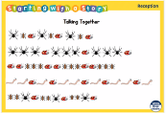  Can you describe the pattern and work out what comes next?  - Tuesday: Make a worm number line. Start at a different number to practice ‘counting on’ e.g. 5, 6, 7, 8 etc. Grow ups can help with the writing numbers or use number cards/display to help with number formation. Can you count on from 8? 10? All the way up to 20.  Now try your worms counting back.  - Wednesday: How many super moves can you do in 1 min? How many skips in 1 minute, can you hula hoop for 1 minute, can you swing your arms for 1 min? Can you record your moves for each activity?  - Thursday: Create your own ‘Yucky Shop’.  How many mini-beasts would I have if I had 10 spiders and 20 worms? How many would there be in half a tin. Make a yucky shopping list.  - Friday: Make string worms of different lengths. Can you compare them with other things? Can you put your worms lengths in order? Can you practice tying knots? Song: a fun way to remember the terms of length and size and ordinal numbers. | - Read a variety of books at home. Favourites can be repeated. Hearing the patterns of language in a story will support your child’s language development.  - Reception age children: Children to read to parents daily. Visit Oxford Owl for free eBooks that link to your child’s book band. You can create a free account.  Complete the linked Play activities for each book.  - Look at recipe books and food magazines. Encourage your child to use their phonics knowledge to decode the ingredients list. Select a recipe and make this together.  - Don’t forget Storytime with Nick  - No new tricky words this week.  - Daily phonics with RWI. Practise the sounds your child is working on either Set 1 Speed Sounds, Set 1 Word Time Reading and Set 1 Spelling or Set 2 Speed Sounds and Set 2 Spelling.  - Enjoy this week’s focus story Superworm https://www.youtube.com/watch?v=7Jnk3XApKBg
Weekly Writing Tasks (Aim to do 1 per day)
- Continue to practise the correct formation of letters (handwriting) linked to the phoneme learned in RWI phonics session. Refer to the letter patter on the Class page of the website.

- Using recipes from books as a guide, ask your child to create their own recipe for their dream meal. They could draw out the ingredients and label them and draw the finished meal. Some children may be able to write a few short sentences as instructions.

- Look at a range of different packages found around the kitchen. Discuss with your child what makes it stand out to a customer. Support them to design a package for a treat of their choice.
Learning Project - to be done throughout the week
The project this week aims to provide opportunities for your child to learn more food. Learning may focus on where different foods originate from, what makes a healthy meal, opportunities to cook etc.
- Healthy/ Unhealthy-
  - Provide your child with a selection of items from your kitchen cupboards. Can they sort them into things that are healthy and unhealthy? Discuss why the food is good for you or bad for you. Look at the Eatwell plate to help figure out which foods they should eat a lot of or not very much of.
- Discuss how exercise is an important part of staying healthy. Watch and complete a 10 minute shake up.

- 5 a day-
  - Support your child to create a food diary to record how many pieces of fruit and vegetables they eat in a day. They could write these using their phonics knowledge or draw a picture of each item.

- Create a collage-
  - Ask your child to draw out a number of fruits or vegetables, large enough to fill a piece of A4 paper. Provide them with a selection of colourful packaging. Can they cut out and collage on to their picture to

- Play shops-
  - Using toy food or old packaging, set up a food shop for your child to act out being the shopkeeper and customer. You could introduce coins to support their developing knowledge of money. Give them a notepad to use as a shopping list to encourage in the moment writing.

- Experimenting with scales-
  - Explore weighing and measuring food on the kitchen scales. Ask, what happens as you place more on the scales?

- Potato/ Vegetable Printing-
  - Using a selection of vegetables available in your kitchen, support your child to print and explore the shapes and patterns created:
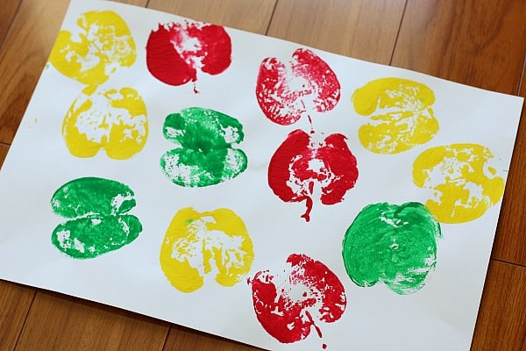
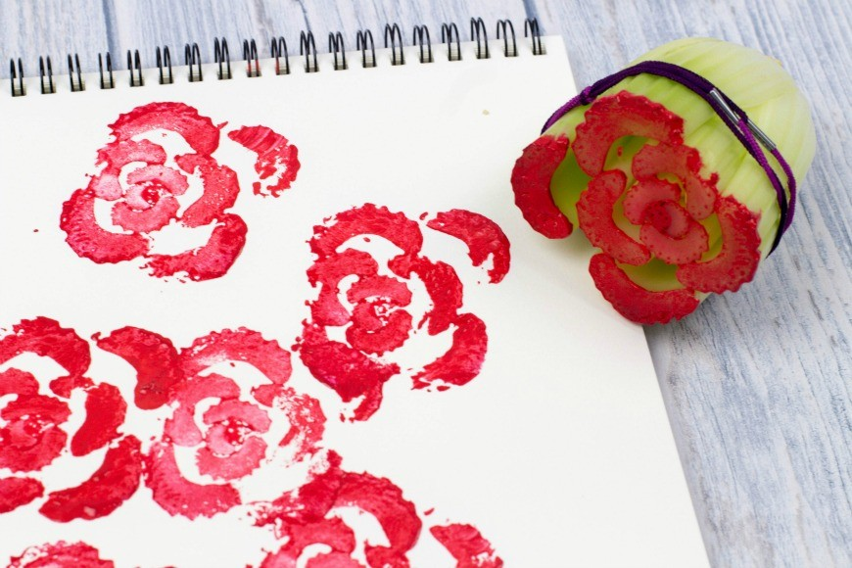
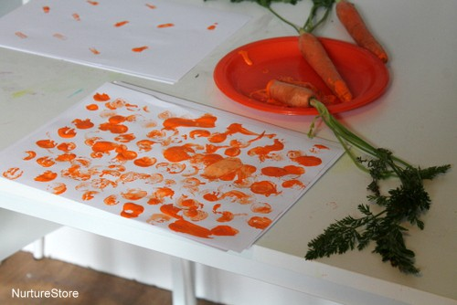

Additional learning resources parents may wish to engage with
If you are working at home, please keep sending us the photographs of your home learning.
Twinkl - to access these resources click on the link - use the offer code UKTWINKLHELPS.

