**100 Books To Try And Read In Year 5 and 6**

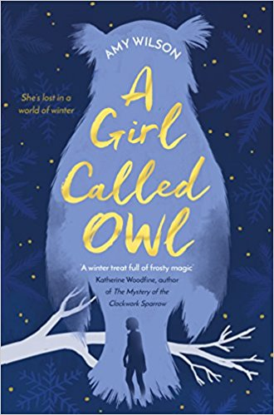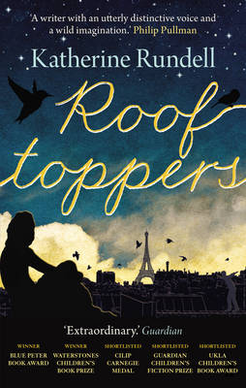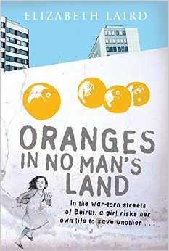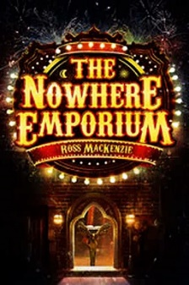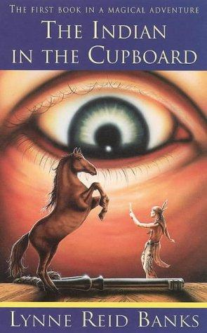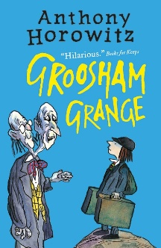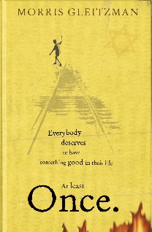

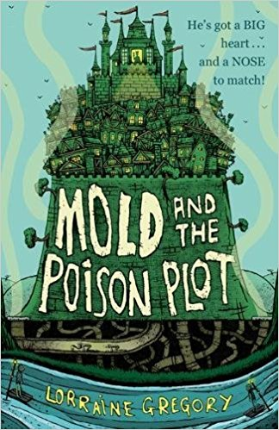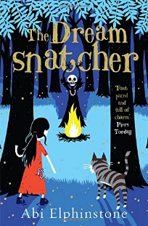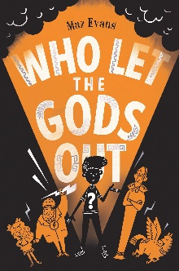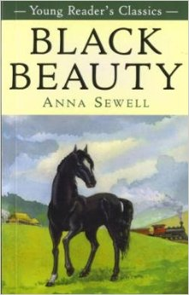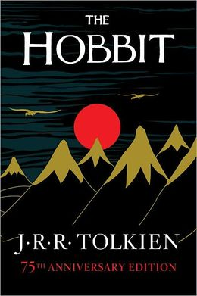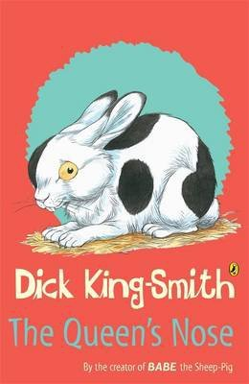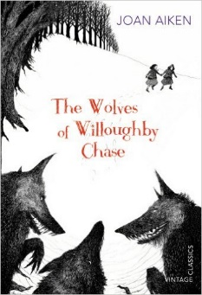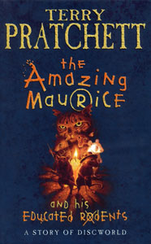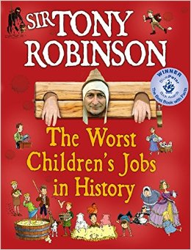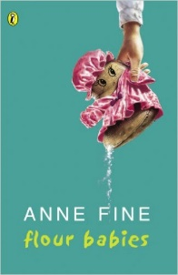 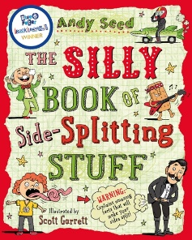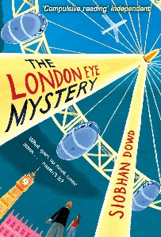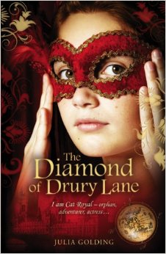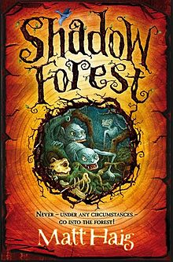

The Silly Book of Side-Splitting Stuff

Andy Seed

Black Beauty

Anna Sewell

The Hobbit

JRR Tolkien

Who Let The Gods Out?  
Maz Evans

The Queen’s Nose

Dick King-Smith

The Wolves of Willoughby Chase

Joan Aiken

The Amazing Maurice and his Educated Rodents

Terry Pratchett

The Worst Children’s Jobs In History

Tony Robinson

The Indian In The Cupboard

Lynne Reed Banks

Flour Babies

Anne Fine

Mold and the Poison Plot

Lorraine Gregory

The Dreamsnatcher

Abi Elphinstone

The London Eye Mystery

Siobhan Dowd

The Diamond of Drury Lane

Julia Golding

Shadow Forest

Matt Haig

A Girl Called Owl

Amy Wilson

Rooftoppers

Katherine Rundell

Oranges in No Man’s Land

Elizabeth Laird

The Nowhere Emporium

Ross Mackenzie

Groosham Grange

Anthony Horowitz

Once

Morris Gleitzmann