Because staff and children see different screens, I have had to borrow a Year 6 child’s login to create instructions for you. Please do not worry if your page looks slightly different!
Completing Assignments
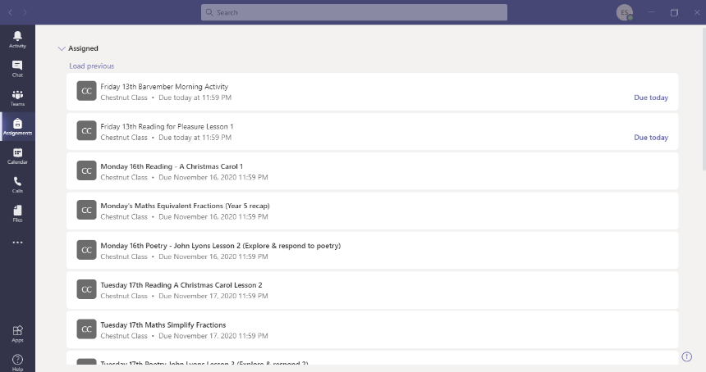
Select assignments from the menu on the left hand side.
Select the assignment you would like to complete.
If your lesson has a work sheet, you will have two options: a pdf which can be downloaded or a link to a Notebook.
Option 1
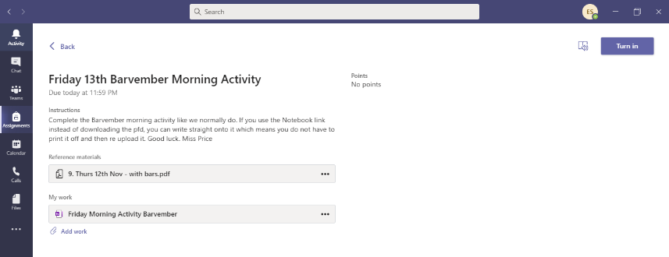
The pdf can be downloaded, printed and written on it the usual way. This will then need to be sent back to us at the end which I will explain later.
Option 2
Option 2
Option 1
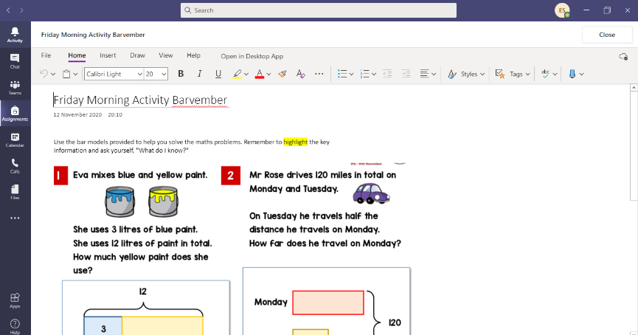
If you want to write straight onto the document (without printing), you can but you need to use the App not the web browser.
Follow the instructions as above but then you would use the ‘My work’ link. Double click on the task which opens up the child’s notebook. This can only be seen by the child and the teacher.
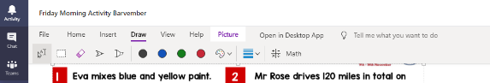
You can then select ‘Draw’ from bar at the top and then select ‘pen’ or the ‘text’ icon to write directly on the pages or type your answers.
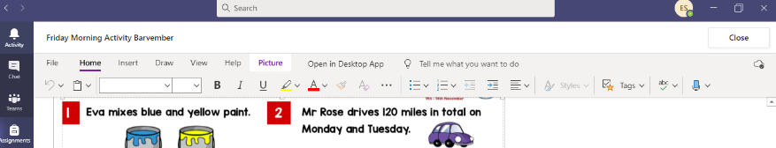
The Notebook automatically saves as you do it so you do not need to press save.
Press ‘close’ once you have completed it.

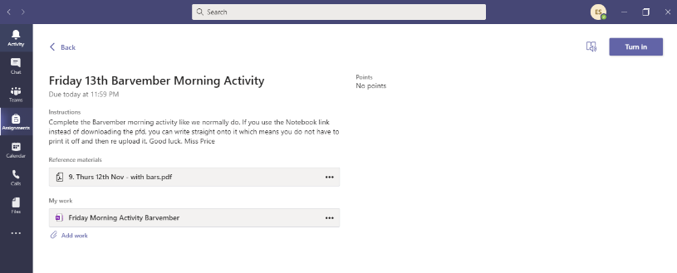
‘Turning in’ your work
‘Turning in your’ work is different depending on how you have completed it.
If you used option 1 (pdf link) and printed your work and written on it, you will need to take a photograph of what you have done and attach it using the ‘add work’ button from the assignment you are working on. This will be the same for lessons that do not have ‘worksheets’ that need downloading (English, Reading and other subjects). You will be expected to take a photograph of the work you have done, upload it and ‘turn it in’ in the same way.
Once you have done this, you can then click the ‘turn in’ button on the top right hand side.
If you used option 2 (the Notebook), you do not need to upload anything, you just press the ‘turn in’ button.
Please make sure you are ‘turning in’ rather than saving to ‘files’.

