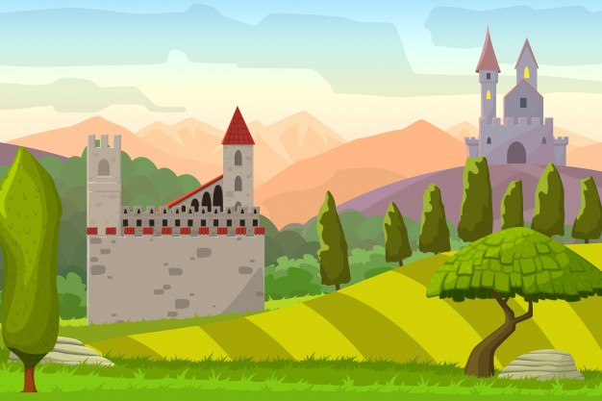

**In Maths we will focus on…**

-reading and writing numbers to 100 in numerals and words.

- recognising the place value of two-digit numbers and comparing and ordering numbers using < > =.

-counting in steps of 2,3, 5 and 10 from any number.

-using number facts to 20 and related facts to 100.

- adding and subtracting two and one digit numbers using apparatus, pictures and mental methods.

- recognising £ and p and combining coins to make amounts.

- making amounts using different combinations.

- solving problems and giving change.

-recalling multiplication and division facts and solving multiplication and division problems using arrays and repeated addition.

**In English we will focus on…**

-reading non-fiction texts to research homes in the past.

- Reading a range of texts including fairy tales.

-writing for different purposes e.g. simple recounts, fact books and missing posters.

-revising all graphemes previously taught and beginning to learn the correct choice of digraph for particular words.

-revise handwriting joins learned in Year 1 and using correct sizing and formation for letters.

-speaking clearly and performing.

**In History we will focus on…**-using secondary sources to research castles.

-Find out about homes in the past and compare how they have changed.

-retelling the story of the Battle of Hastings and learning about William the Conqueror. .  
-drawing simple timelines to sequence events.  
-comparing past and present homes in our locality.

-asking questions to find out about the past.

**In Music we will focus on…**- using our voices with expression and creativity.

- learning rhymes and chants.

- playing non-tuned instruments.

- learning to sing a range of songs for our Christmas production.

**In Science we will focus on…**

**-** identifying and comparing the suitability of a variety of everyday materials for different uses  
- comparing how things move on different surfaces.

-finding out how the shapes of solid objects made from some materials can be changed.

-identifying and classifying materials.

-carrying out simple tests and making observations.

-gathering data in order to answer questions.

Castles in the Sky

Year 2 Autumn Term 2021

**In Art/DT we will focus on…**-mixing paints and experimenting with shades.-look at famous portraits and painting our own.   
-Artists: Paul Klee, Escher

Designing and building a structure.

**In PE we will focus on…**-developing fundamental movements of speed, agility and quickness.

-improving and refining basic ball skills.

-sticking and fielding games.

**In RE/PSHE we will focus on…**

-reading Bible story ‘Jonah and the Whale’.

-learning about making choices and explain how actions affect others.

-understanding the term ‘Morals”.

-comparing the festivals of Christmas and Hannukah.

**In Computing we will focus on…**-e-safety and what to do if we feel unsafe on the internet.

-independently logging on and shutting down IT equipment.

-presentation skills-using creative programs.