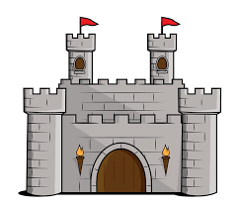
Castles in the Sky
Autumn Term Home Learning Projects Year 1
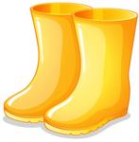
Please complete 2 of these projects each half term so that by the Christmas Holidays you will have completed at least 4 of the activities below. These activities are designed to get your creative juices flowing and to be a great opportunity to develop your learning with support from someone at home. We are really looking forward to sharing what you have learnt and the new skills you have developed. When you have some Home Learning to share, you could bring it in to show or upload a photo and/or video to Tapestry.
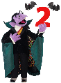  Counting in 2s  Practise counting in 2s at home, on the way to school, in the car, at the supermarket, wherever you like!  Why not demonstrate your skills by recording yourself, taking a photo or drawing a picture. | 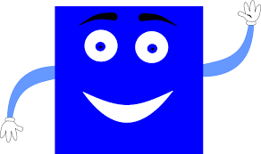  Shape Safari  Hunt for 2D and 3D shapes around your home or outside.  You could record what you find using photos, pictures or even a tally chart. | Autumn Walk  Go on a welly walk with your family and take a photo of some of the signs of Autumn that you find.  It might inspire you to draw or paint an Autumn picture!
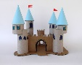  Castle Model  Make a model of a castle (real or fairy tale) and practise your cutting and drawing skills.  Maybe you could tell us about who lives in your castle, you could even write a story about them! | 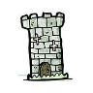  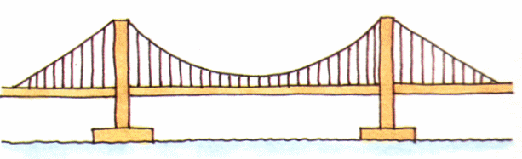  Visit a Bridge or Castle  Visit a castle with your family or go  on a virtual tour using the internet!  Perhaps you could make a map or a guidebook based on your visit or share some photos with us! | 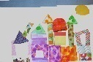  Materials Collage  We are investigating materials in Science. Make a collage using materials that you find. Perhaps link it to our learning about Castles or Bridges? You could label the materials that you use or try to make a collage using only one type e.g. just shiny materials.
Or get creative and amaze us with some of your own choice topic related learning!
Don’t forget to read as often as possible at home and practice reading and spelling the Year 1 Common Exception words in the phonics folder or on Tapestry.

